**Class Practice - 8**

**MIS 64038**

1. Plot the following graph and label as shown:

ggplot(economics, aes(date, unemploy)) + geom_line() +

labs(title=caption, y="Unemployment", x="Year", caption=caption)

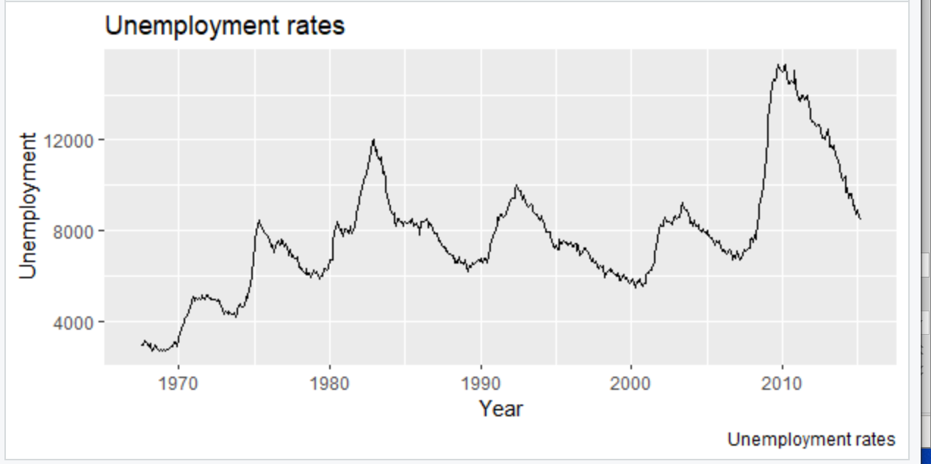

1. Execute the following program to annotate the graph:

p <- ggplot(cars, aes(displ, cty)) +

geom_point(

data = filter(cars, manufacturer == "audi"),

colour = "red",

size = 3

) +

geom_point()

p +

annotate(

geom = "curve", x = 3, y = 35, xend = 2.8, yend = 20,

curvature = .3, arrow = arrow(length = unit(2, "mm"))

) +

annotate(geom = "text", x = 3.1, y = 35, label = "Audi", hjust = "left")

install.packages("ggforce")

library(ggforce)

ggplot(cars, aes(displ, hwy)) +

geom_point() +

ggforce::geom_mark_ellipse(aes(label = cyl, group = cyl))

install.packages("gghighlight")

library("gghighlight")

ggplot(cars, aes(displ, cty,

colour = factor(drv))) +

geom_point() +

gghighlight::gghighlight() +

facet_wrap(vars(drv))

1. Try following plots:

**Plot 1:**

ggplot(cars, aes( displ,cty)) +

geom_point() +

geom_smooth()

**Plot 2:**

ggplot(cars, aes(cty,displ)) +

geom_point() +

geom_smooth()

**Plot 3:**

ggplot(cars, aes(displ, cty)) +

geom_point() +

geom_smooth() +

coord_flip()

1. Using “Annotation” discussed earlier, highlight car type “Honda”
2. Using ggforce() to highlight the “Class” of cars on “City” mileage based on engine (displ)
3. Using gghighlight() cluster “transmission” type